

CyberShield 360: Design and Analysis of an AI-Enabled Enterprise Cybersecurity Platform
Submitted in the partial fulfilment for the Course of

CSA1012 – Software Engineering

to the award of the degree of

BACHELOR OF TECHNOLOGY

Submitted by
P.Sai Surya Tej (192572044)

UNDER THE SUPERVISION OF
Dr. K. Anita Davamani

SIMATS ENGINEERING
Saveetha Institute of Medical and Technical Sciences
Chennai-602105
July-2026

ACKNOWLEDGEMENT

We would like to express our heartfelt gratitude to all those who supported and guided us throughout the successful completion of our Capstone Project. We are deeply thankful to our respected Founder and Chancellor, Dr. N.M. Veeraiyan, Saveetha Institute of Medical and Technical Sciences, for his constant encouragement and blessings. We also express our sincere thanks to our Pro-Chancellor, Dr. Deepak Nallaswamy Veeraiyan, and our Vice-Chancellor, Dr. S. Suresh Kumar, for their visionary leadership and moral support during the course of this project.

We are truly grateful to our Director, Dr. Ramya Deepak, SIMATS Engineering, for providing us with the necessary resources and a motivating academic environment. Our special thanks to our Principal, Dr. B. Ramesh for granting us access to the institute’s facilities and encouraging us throughout the process. We sincerely thank our Head of the Department, Dr K. Anita Davamani for his continuous support, valuable guidance, and constant motivation.

We are especially indebted to our guide Dr K. Anita Davamani for his creative suggestions, consistent feedback, and unwavering support during each stage of the project. We also express our gratitude to the Project Coordinators, Review Panel Members (Internal and External), and the entire faculty team for their constructive feedback and valuable inputs that helped improve the quality of our work. Finally, we thank all faculty members, lab technicians, our parents, and friends for their continuous encouragement and support.

Signature With Student Name
P. Sai Surya Tej (192572044)

Abstract

The rapid growth of digital transformation, cloud computing, and interconnected enterprise systems has significantly increased the complexity and frequency of cyber threats. Traditional cybersecurity solutions, which primarily rely on signature-based detection and manual analysis, are no longer sufficient to identify sophisticated attacks such as ransomware, phishing, insider threats, Advanced Persistent Threats (APTs), and zero-day vulnerabilities. Enterprise Security Operations Centers (SOCs) face the challenge of analyzing massive volumes of security logs generated from networks, endpoints, cloud platforms, and applications, resulting in delayed incident detection, fragmented visibility, and slower response times.
This case study presents CyberShield 360, an AI-powered Enterprise Cybersecurity Monitoring and Threat Intelligence System designed to enhance organizational security through intelligent automation and real-time threat detection. The proposed platform integrates Artificial Intelligence (AI), Machine Learning (ML), behavioral analytics, and global threat intelligence feeds to continuously monitor enterprise infrastructure, detect anomalous activities, predict potential cyber threats, and automate incident response. By correlating security events from multiple sources, the system minimizes false positives, improves threat visibility, and enables proactive security management.
The proposed solution follows software engineering principles such as modularity, scalability, maintainability, reliability, usability, and security to ensure the development of a robust and enterprise-ready cybersecurity platform. An Agile Scrum development methodology integrated with DevSecOps practices is recommended to support continuous development, rapid deployment, and evolving security requirements. The platform includes modules for data collection, AI-based threat detection, threat intelligence integration, automated response, compliance management, and interactive security dashboards.
The expected outcomes of CyberShield 360 include faster threat detection, reduced incident response time, improved regulatory compliance, enhanced protection against advanced cyberattacks, and greater operational efficiency for security teams. Although challenges such as implementation cost, AI model maintenance, legacy system integration, and privacy concerns remain, the proposed platform provides a scalable and intelligent approach to strengthening enterprise cybersecurity. Overall, CyberShield 360 demonstrates how AI-driven technologies and software engineering practices can be combined to build a modern, resilient, and proactive cybersecurity solution capable of addressing the evolving threat landscape.

1. System Requirements Analysis

1.1 System Objectives
CyberShield 360 aims to give enterprises unified, AI-driven visibility into their security posture by continuously monitoring network traffic, endpoints, cloud resources, and user activity; detecting sophisticated threats that bypass signature-based tools; and automating incident response to reduce dwell time and analyst workload. The platform must correlate fragmented security signals into a single, prioritized view and support regulatory compliance.

1.2 Functional Requirements
# | Functional Requirement | Description
FR1 | Multi-source data ingestion | Continuously collect network traffic, endpoint (EDR), cloud, and identity/user-activity logs.
FR2 | AI/ML threat detection | Detect malware, phishing, ransomware, insider threats, and behavioral anomalies using trained ML models.
FR3 | Threat intelligence integration | Correlate internal events with external feeds (IOCs, CVEs, OSINT) for enriched risk context.
FR4 | Incident prioritization & scoring | Rank detected incidents by severity/risk score to focus analyst attention.
FR5 | Automated response (SOAR) | Trigger predefined playbooks — isolate endpoint, block IP, revoke session — for high-confidence threats.
FR6 | Security dashboards & analytics | Provide real-time visual dashboards, drill-down reports, and historical trend analysis.
FR7 | Alerting & notification | Notify SOC analysts/administrators via email, SMS, or in-app alerts on critical events.
FR8 | Compliance reporting | Generate audit-ready reports mapped to standards such as ISO 27001, NIST, and GDPR.

1.3 Non-Functional Requirements & Quality Attributes
Because CyberShield 360 protects business-critical infrastructure, its non-functional requirements are as important as its functional ones — a slow or unavailable security platform is itself a security risk.
Quality Attribute | Requirement
Scalability | Must handle millions of log events per second across a growing number of endpoints and cloud accounts without performance loss.
Performance | Threat detection and alert generation must occur in near real time (target: under 5 seconds from event ingestion to alert).
Reliability | The platform must correctly detect threats with minimal false negatives and maintain data integrity across processing stages.
Availability | Core monitoring services must operate 24/7 with high uptime (target 99.9%), since security blind spots are unacceptable.
Security | The platform itself must be hardened — encrypted data in transit/at rest, strict RBAC, and audit logging of all admin actions.
Maintainability | Individual services (detection, response, reporting) must be independently updatable, e.g., to retrain ML models without downtime.
Interoperability | Must integrate with existing SIEM/EDR/firewall tools and external threat-intel feeds via open APIs and standard formats (STIX/TAXII).
Compliance | Must support regulatory frameworks (ISO 27001, NIST CSF, GDPR) through auditable logs and configurable data-retention policies.

2. Selected Software Architecture

2.1 Architectural Style
A Hybrid Event-Driven Microservices Architecture is selected, combining:
- Event-Driven Architecture (EDA) for the ingestion and streaming backbone (Kafka), since security data arrives continuously and unpredictably from thousands of sources and must be processed as a live stream rather than in scheduled batches.
- Microservices Architecture for the AI/ML, detection, response, and reporting capabilities, since each function has distinct scaling needs, update cadence, and failure isolation requirements.
- A Layered organization (source → ingestion → processing → data → services → gateway → presentation) to keep the overall system understandable despite its distributed nature.

2.2 Justification
Enterprise security monitoring generates extremely high-volume, high-velocity data (millions of events/second across a large organization) that a monolithic or purely layered application cannot process in real time. An event-driven backbone allows every downstream service — ML inference, correlation, alerting — to react to events independently and in parallel. Microservices additionally allow the platform to:
- Scale only the components under load (e.g., add ML inference replicas during an attack spike) instead of scaling the entire application.
- Update or retrain individual ML models and add new detection services without redeploying or risking the whole platform.
- Isolate failures — a slow reporting service cannot block real-time detection and response.
- Integrate cleanly with heterogeneous, pre-existing enterprise tools (firewalls, EDR, IAM, SIEM) via well-defined APIs and event topics.
Pure microservices without an event backbone would create tight, synchronous request chains that cannot absorb bursty security telemetry; a purely monolithic layered design would not scale or allow independent deployment of ML components. The hybrid model was therefore judged the best fit.

3. Software Architecture Diagram
The diagram below shows the complete structure of CyberShield 360: data sources, the ingestion/streaming backbone, the AI/ML processing layer, the data and knowledge layer, the application microservices, the API gateway, and the presentation layer, along with the automated feedback loop from the response service back to enforcement points.
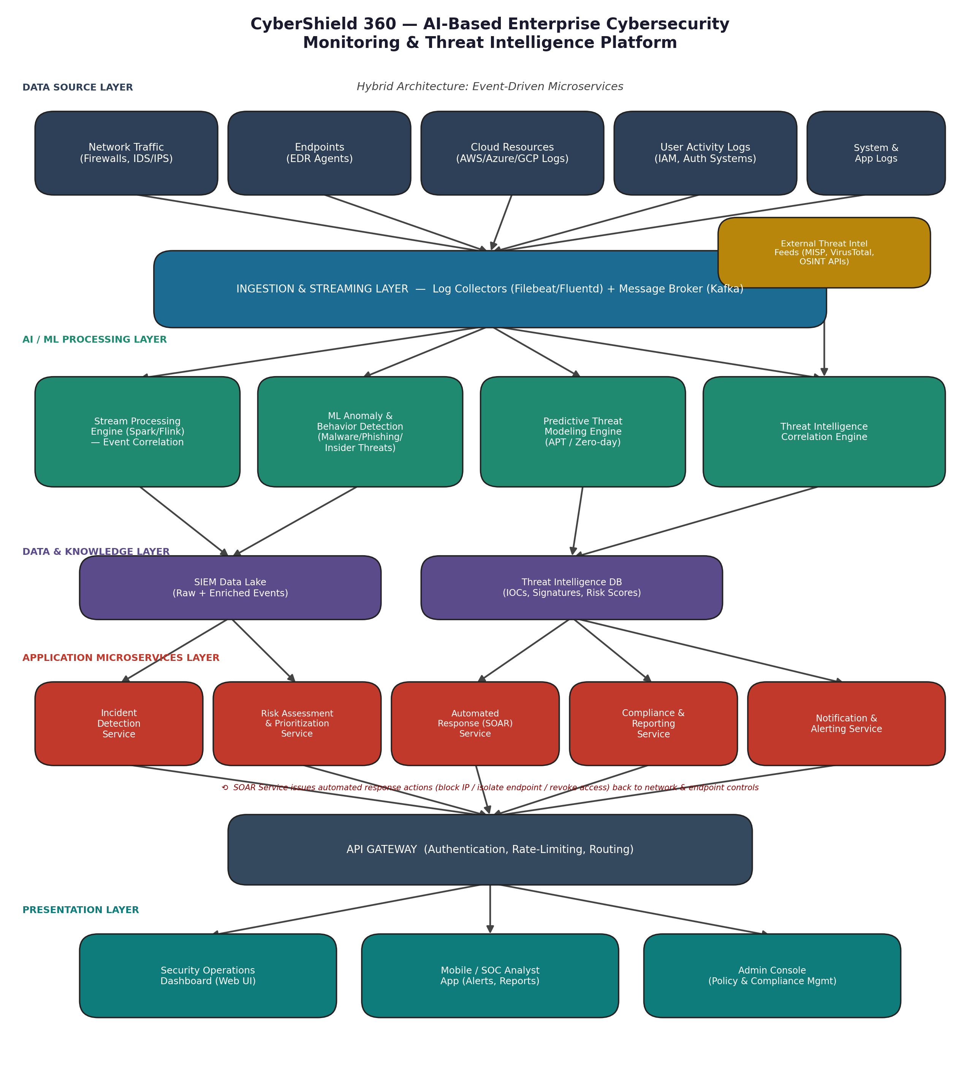
Figure 1: CyberShield 360 — layered event-driven microservices architecture.

4. Components, Interactions & Workflow

4.1 Component Responsibilities and Communication
Component | Responsibility | Communication Mechanism
Log Collectors / Agents | Capture raw events from network devices, endpoints, cloud services, and identity systems. | Push events over TLS to the message broker (lightweight forwarders, e.g., Filebeat/Fluentd).
Ingestion & Streaming Layer (Kafka) | Buffer, normalize, and route high-volume event streams to downstream consumers. | Publish–subscribe messaging; decouples producers (sources) from consumers (ML services).
AI/ML Processing Services | Run anomaly detection, classification, and predictive models on streamed events. | Consume from Kafka topics; expose gRPC/REST inference endpoints; write results to the data layer.
Threat Intelligence Engine | Enrich internal events with external IOC/OSINT feeds; compute contextual risk. | Pulls feeds via STIX/TAXII and REST APIs on a schedule; correlates against the SIEM data lake.
SIEM Data Lake / Threat-Intel DB | Persist raw, enriched, and historical security data for analytics and audit. | Written to by processing services; queried by microservices and dashboards via internal APIs.
Incident Detection & Risk Services | Aggregate ML outputs into scored, prioritized incidents. | Internal REST/event calls; publishes incident events to the response and alerting services.
Automated Response (SOAR) Service | Execute containment playbooks (isolate host, block IP, revoke token). | Calls firewall/EDR/IAM APIs directly; confirms and logs action outcomes back to the data layer.
Notification & Reporting Services | Send alerts and generate compliance reports. | Push notifications (email/SMS/webhook) and scheduled report generation via internal APIs.
API Gateway | Single secure entry point: authentication, rate-limiting, request routing. | Fronts all microservices; issued JWT/OAuth2 tokens validate every downstream call.
Dashboards / Consoles | Present real-time visibility and controls to SOC analysts and administrators. | Consume REST/WebSocket APIs through the gateway for live updates.

4.2 End-to-End Workflow
At runtime, data flows through the system as a continuous pipeline rather than a single request/response cycle:
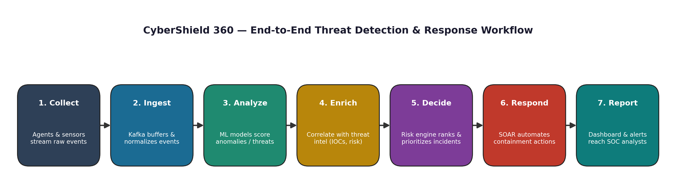
Figure 2: End-to-end threat detection and automated response workflow.
- Collect — agents and sensors on endpoints, network devices, and cloud accounts continuously stream raw events.
- Ingest — the Kafka-based streaming layer buffers and normalizes millions of events per second, decoupling producers from consumers.
- Analyze — ML models (anomaly detection, classification, predictive modeling) score events for malicious behavior in near real time.
- Enrich — the threat intelligence engine correlates internal findings with external IOC/OSINT feeds to add risk context.
- Decide — the risk assessment service aggregates scored, enriched events into prioritized incidents.
- Respond — for high-confidence threats, the SOAR service automatically executes containment playbooks (isolate endpoint, block IP, revoke access), looping back to the enforcement points at the data-source layer.
- Report — dashboards, mobile alerts, and compliance reports surface results to SOC analysts and administrators through the API gateway.

5. Quality Attributes Discussion
The chosen architecture was evaluated against the key quality attributes required for an enterprise security platform:
Attribute | How the Architecture Addresses It
Scalability | Kafka-based streaming decouples ingestion from processing, so ML and microservice instances can be scaled horizontally (e.g., Kubernetes pods) independently as log volume grows.
Security | API Gateway enforces authentication/authorization on every call; data is encrypted in transit (TLS) and at rest; microservice isolation limits blast radius of a compromised component.
Performance | Stream processing (Spark/Flink) and in-memory model inference minimize detection latency; hot paths (detection, alerting) are separated from slower batch analytics (reporting).
Reliability | Kafka's durable, replicated log prevents event loss; each microservice can retry/failover independently without bringing down the whole platform.
Maintainability | Loose coupling between microservices allows ML models, playbooks, or dashboards to be updated/redeployed independently with minimal regression risk.
Availability | Stateless microservices behind the gateway support redundant deployment across nodes/zones, enabling rolling upgrades with near-zero downtime.

6. Architectural Justification & Trade-offs

6.1 Rationale
The hybrid event-driven microservices approach directly maps to the problem statement's core challenge: correlating massive, fragmented security data streams from independent tools into timely, actionable intelligence. Decoupled services mean the platform's weakest link (e.g., a compliance-report job) cannot delay life-critical detection and response paths.

6.2 Trade-offs Considered
- Operational complexity: running many independent services requires container orchestration (e.g., Kubernetes), centralized logging, and service-mesh style observability — a real cost compared to a simpler monolith, but necessary at enterprise scale.
- Eventual consistency: because services communicate asynchronously via Kafka, there is a small propagation delay between an event occurring and every service reflecting it; this is acceptable given real-time targets are in seconds, not milliseconds.
- Increased infrastructure cost: message brokers, multiple databases, and service replicas cost more to run than a single application — justified by the scalability and resilience an enterprise security platform requires.

6.3 Future Enhancements & Long-Term Maintainability
- New detection capabilities (e.g., a new ML model for a novel attack class) can be added as an independent microservice subscribing to existing Kafka topics, without modifying the rest of the system.
- The API Gateway provides a stable integration point for future clients (e.g., a new mobile app or third-party SOAR integration) without exposing internal service topology.
- Because state and processing logic are cleanly separated by layer, the platform can evolve to adopt newer technologies (e.g., a different stream processor or model-serving framework) with localized change.
- The architecture supports multi-cloud and hybrid deployment, letting the platform scale geographically as the organization grows.

7. Data Architecture & Information Model
CyberShield 360 treats data as a first-class architectural concern: the same event may be read by an ML inference service, a correlation engine, a compliance report generator, and an analyst dashboard, each with different latency, consistency, and retention needs. The data architecture therefore separates a fast, append-only event backbone from a set of specialised stores optimised for their consumers, rather than forcing every workload onto a single database.

7.1 Core Data Entities
The platform's information model is organised around a small set of core entities that flow through the pipeline described in Section 4. The table below summarises each entity, its role, and its key attributes.
Entity | Description | Key Attributes
Raw Event | An unmodified record captured by an agent or sensor. | source_id, timestamp, event_type, payload
Normalized Event | A raw event mapped to the platform's common schema. | event_id, entity_refs, normalized_fields
Threat Indicator (IOC) | An external signal (hash, IP, domain, CVE) from a threat-intel feed. | indicator_id, type, confidence, source_feed
Detection | An ML model's scored output for a normalized event. | model_id, score, label, feature_vector_ref
Incident | An aggregated, prioritized case built from one or more detections. | incident_id, severity, status, related_events
Playbook Action | A recorded automated or manual response step. | action_id, incident_id, action_type, outcome
Asset | An enterprise entity being protected (host, account, cloud resource). | asset_id, owner, criticality, tags
Audit Record | An immutable log of an administrative or system action. | actor, action, target, timestamp

7.2 Data Flow and Storage Tiers
Data moves through three broad tiers as it ages and its access pattern changes. The hot tier (in-memory and fast SSD-backed stores) holds the last few hours of normalized events and active incidents so that detection and dashboards stay within the sub-five-second latency target. The warm tier (the SIEM data lake) holds enriched, queryable history for weeks to months, supporting analyst investigation and drill-down. The cold tier (object storage with lifecycle policies) holds long-term archives required for compliance and forensic replay, at a much lower cost per gigabyte.
- Hot tier: Kafka topics and an in-memory feature store back the ML and correlation services.
- Warm tier: the SIEM data lake serves dashboards, ad-hoc analyst queries, and short-term trend analysis.
- Cold tier: encrypted object storage retains raw and enriched data for the periods required by GDPR, ISO 27001, and internal policy.

7.3 Data Retention & Lifecycle Policy
Data Category | Hot Tier | Warm Tier | Cold Archive
Raw network/endpoint events | 24 hours | 30 days | 1 year
Normalized & enriched events | 24 hours | 90 days | 2 years
Incidents & response actions | Active lifetime | 1 year after closure | 7 years
Threat intelligence indicators | Active subscription | Rolling 180 days | Not archived (re-fetched)
Audit & administrative logs | N/A | 1 year | 7 years

Retention periods above are illustrative defaults; actual values are configurable per tenant to satisfy sector-specific regulatory obligations (for example, longer retention for financial or healthcare customers).

8. Security Architecture of the Platform Itself
A security-monitoring platform is a high-value target in its own right: compromising it would blind an enterprise to real attacks. CyberShield 360 therefore applies zero-trust principles internally, not only to the traffic it monitors.

8.1 Identity, Authentication & Access Control
- Every human and service identity authenticates through OAuth2/OIDC; no component trusts network location alone.
- Role-Based Access Control (RBAC), extended with attribute-based rules for tenant and data-sensitivity scoping, governs what each analyst or service account can see and do.
- Administrative actions (policy changes, playbook edits, user management) require multi-factor authentication and are always written to the audit log.
- Service-to-service calls use short-lived JWTs issued by the API Gateway's identity provider, validated on every hop rather than only at the perimeter.

8.2 Data Protection
- All data in transit uses TLS 1.2+; internal service-mesh traffic uses mutual TLS so services authenticate each other, not just the caller's token.
- Data at rest in the SIEM data lake and cold archive is encrypted using envelope encryption, with keys managed by a dedicated key-management service rather than embedded in application config.
- Sensitive fields (credentials observed in logs, personal data subject to GDPR) are tokenized or redacted before persistence, keeping raw values out of long-term storage.

8.3 Network Segmentation & Isolation
Microservices are grouped into security zones (ingestion, detection, response, presentation) with default-deny network policies between zones. Only the specific ports and protocols each workflow requires are explicitly allowed, so a compromise in one zone cannot freely reach another.

8.4 Secrets & Credential Management
API keys for external integrations (EDR, firewall, IAM, threat-intel feeds) and database credentials are stored in a dedicated secrets manager and injected into services at runtime, never committed to source control or baked into container images. Secrets are rotated on a scheduled basis and immediately on suspected exposure.

8.5 Securing the AI/ML Pipeline
- Training data and model artifacts are versioned and checksummed so a deployed model can be traced back to its exact training set.
- Inference inputs are validated and bounded to reduce exposure to adversarial or malformed inputs designed to evade detection.
- Model performance is continuously compared against a held-out baseline to catch silent drift or data poisoning before it degrades detection quality.9. Deployment & Infrastructure Architecture

9.1 Containerization & Orchestration
Every microservice is packaged as an independently deployable container and orchestrated on Kubernetes. Namespaces separate environments (development, staging, production) and, within production, separate tenants for larger enterprise deployments. Horizontal Pod Autoscaling reacts to queue depth and CPU/memory utilization so that, for example, ML inference pods scale out automatically during an attack spike without manual intervention.

9.2 CI/CD Pipeline
Stage | Purpose
Build | Compile/package each service and its container image on every commit.
Automated Test | Run unit, integration, and contract tests against the new image.
Security Scan | Static analysis, dependency vulnerability scan, and container image scan.
Staging Deploy | Deploy to a staging cluster mirroring production topology.
Canary Release | Route a small percentage of production traffic to the new version.
Full Rollout / Rollback | Promote to 100% on healthy metrics, or automatically roll back on error-rate spikes.

9.3 Multi-Region / Multi-Cloud Topology
For large enterprises with a global footprint, ingestion and detection services are deployed regionally close to the data sources they monitor, reducing latency and keeping data within required jurisdictions. A central control plane aggregates cross-region incident and reporting data, while region-local clusters continue independent detection and response even if connectivity to the central plane is temporarily lost.

9.4 Disaster Recovery & Business Continuity
Failure Scenario | Recovery Approach | Target RTO / RPO
Single service crash | Kubernetes restarts the pod; stateless design avoids data loss. | Seconds / Zero
Availability-zone outage | Traffic shifts to healthy zones behind the load balancer. | Under 1 minute / Zero
Kafka broker failure | Replicated partitions promote a surviving replica to leader. | Under 1 minute / Zero
Regional outage | Fail over to a secondary region using replicated data-lake snapshots. | Under 30 minutes / Under 5 minutes

10. API & Integration Strategy

10.1 API Gateway Policies
- Every external request is authenticated (OAuth2/JWT) and rate-limited per client to protect backend services from abusive or runaway callers.
- APIs are versioned in the URL path (e.g. /v1/incidents) so existing integrations keep working while new capabilities are added.
- Request and response schemas are validated at the gateway, catching malformed integration traffic before it reaches internal services.

10.2 External Integration Matrix
External System | Protocol | Direction | Purpose
SIEM (existing enterprise) | REST / Syslog | Inbound & Outbound | Exchange enriched events and forward correlated alerts.
EDR platforms | REST API | Inbound & Outbound | Ingest endpoint telemetry; issue isolate/quarantine actions.
Firewalls / NGFW | REST / API | Outbound | Push automated block rules from the SOAR service.
IAM / SSO providers | SAML / OIDC | Inbound & Outbound | Authenticate users; revoke sessions during response.
Threat-intel feeds | STIX/TAXII, REST | Inbound | Pull IOC and vulnerability context on a schedule.
Ticketing (e.g. ServiceNow, Jira) | REST API | Outbound | Create and update tickets for incidents requiring human follow-up.
Cloud provider APIs (AWS/Azure/GCP) | REST API | Inbound | Collect cloud configuration and activity logs.

10.3 Internal Service Contracts
Kafka topic schemas are versioned using a schema registry, so producers and consumers can evolve independently: a new optional field can be added without breaking existing consumers, and breaking changes require a new topic version rather than an in-place change. This contract discipline is what allows individual microservices to be updated on independent release schedules, as described in Section 6.3.
11. Testing, Validation & Quality Assurance Strategy

11.1 Test Levels
Test Level | Scope | Example
Unit | Individual functions/classes within a single service. | Validating a risk-scoring formula's edge cases.
Integration | A service and its direct dependencies (DB, Kafka topic). | Confirming a detection service correctly consumes a Kafka topic.
Contract | Producer/consumer schema compatibility. | Verifying a new event field doesn't break existing consumers.
End-to-end | The full pipeline from ingestion to response. | Injecting a simulated malware event and confirming an endpoint is isolated.

11.2 Performance & Load Testing
Because the platform's core requirement is handling millions of events per second, load tests simulate realistic and worst-case ingestion bursts (e.g., a distributed denial-of-service or a fast-spreading worm generating log storms) to confirm the streaming layer and detection services scale horizontally without breaching the five-second detection latency target. Soak tests run the platform under sustained load for extended periods to catch memory leaks or slow degradation that shorter tests would miss.

11.3 ML Model Validation
- Each model is validated against held-out labeled data using precision, recall, and F1, with particular attention to false-negative rate, since a missed detection is the costliest failure mode.
- Production predictions are continuously monitored for drift against the training distribution, triggering a retraining review when input patterns shift significantly.
- Adversarial and red-team-crafted samples are periodically run against the models to test resilience against evasion techniques.

11.4 Security Testing
- Regular penetration testing targets the API Gateway, authentication flows, and inter-service communication.
- Chaos engineering exercises deliberately fail individual services or Kafka brokers in staging to confirm the platform degrades gracefully rather than catastrophically.
- Purple-team exercises pair the platform's own detection/response capability against simulated attacker techniques (mapped to MITRE ATT&CK) to validate real-world detection coverage.
12. Project Plan: Phases, Milestones & Dependencies
Delivering CyberShield 360 is sequenced so that the event backbone and data foundations exist before higher-level detection, response, and reporting capabilities are built on top of them. The table below summarises each phase, its principal deliverables, and what it depends on.
Phase | Key Deliverables | Depends On
1. Requirements & Architecture Finalization | Signed-off functional/non-functional requirements; architecture design (this report). | Stakeholder workshops
2. Ingestion & Streaming Backbone | Log collectors/agents; Kafka cluster; schema registry. | Phase 1
3. Data Layer & Storage Tiers | SIEM data lake; hot/warm/cold storage policies. | Phase 2
4. AI/ML Detection Services | Trained anomaly/classification models; inference services. | Phases 2-3
5. Threat Intelligence Integration | STIX/TAXII feed connectors; enrichment/correlation engine. | Phase 3
6. Incident Scoring & SOAR | Risk-scoring service; automated response playbooks. | Phases 4-5
7. Dashboards, Alerting & Compliance Reporting | API Gateway; analyst dashboards; ISO/NIST/GDPR report templates. | Phases 4-6
8. Hardening, Testing & Pilot Deployment | Load/security/chaos testing; limited-scope pilot with a subset of data sources. | Phases 2-7
9. Production Rollout & Continuous Improvement | Full rollout; feedback loop for model retraining and new detection services. | Phase 8

12.1 Dependency Notes
- The streaming backbone (Phase 2) is the critical-path dependency for nearly every later phase; delays here cascade through the whole plan.
- AI/ML detection (Phase 4) and threat-intelligence integration (Phase 5) can proceed in parallel once the data layer (Phase 3) is available, shortening the overall timeline.
- Compliance reporting (Phase 7) depends on incident data being reliably scored and stored, so its templates are finalized only after Phases 4-6 stabilize.
- Pilot deployment (Phase 8) intentionally runs against a limited set of real data sources before Phase 9, so issues surface at small scale first.

13. Risk Management & Mitigation Plan
Risks are grouped into technical, security, operational, and project-delivery categories. Each is rated for likelihood and impact and paired with a concrete mitigation, so the plan is actionable rather than a generic list of concerns.
Risk | Category | Likelihood | Impact | Mitigation
ML models produce excessive false negatives | Technical | Medium | High | Continuous validation against labeled data; human-in-the-loop review for low-confidence cases.
Streaming layer cannot keep up with peak event volume | Technical | Medium | High | Load testing at worst-case volumes; horizontal autoscaling of consumers.
Platform itself is compromised (insider or external) | Security | Low | Critical | Zero-trust internal architecture; strict RBAC; continuous audit logging.
Alert fatigue reduces analyst responsiveness | Operational | High | Medium | Risk-based prioritization/scoring; tunable alert thresholds; noise-reduction correlation.
Vendor/tool lock-in limits future flexibility | Operational | Medium | Medium | Open APIs and standard formats (STIX/TAXII, REST) at every integration boundary.
Integration delays with legacy enterprise tools | Project | Medium | Medium | Early proof-of-concept integrations during Phase 2-3; phased onboarding of data sources.
Scope creep from stakeholder feature requests | Project | Medium | Medium | Change-control process tied to the phase plan in Section 12.
Skill gaps in Kubernetes/Kafka/ML operations | Project | Medium | Medium | Targeted training plus staged hiring aligned to phase timelines.
Regulatory requirements change during development | Compliance | Low | High | Configurable retention/reporting policies rather than hard-coded rules.

14. Cost & Resource Estimation

14.1 Team Composition
Role | Primary Responsibility
Solution/Enterprise Architect | Owns the overall architecture and cross-team technical decisions.
Backend/Platform Engineers | Build ingestion, data, and microservice layers.
ML/Data Scientists | Develop and validate detection and anomaly models.
Security Engineers | Harden the platform itself and run security testing.
DevOps/SRE Engineers | Own CI/CD, Kubernetes operations, and reliability.
SOC/Domain Analysts | Define detection logic, playbooks, and validate real-world usability.
QA Engineers | Own the test strategy described in Section 11.

14.2 Infrastructure Cost Drivers
The dominant recurring costs are proportional to event volume and retention, not to the number of features shipped, which is an important planning consideration for enterprises scoping the platform for their environment.
Cost Driver | Scales With | Relative Weight
Compute (microservices + ML inference) | Event throughput and number of active models | High
Streaming backbone (Kafka cluster) | Event volume and retention window | High
Data lake storage (warm + cold tiers) | Retention period and number of data sources | Medium-High
Threat-intelligence feed licensing | Number and quality of external feeds subscribed | Medium
Networking / data egress | Multi-region or multi-cloud replication | Medium
Third-party integration licensing | Number of connected SIEM/EDR/IAM tools | Low-Medium

15. Comparison with Alternative Architectural Styles
Section 2 selected a hybrid event-driven microservices architecture. The table below makes the comparison against the alternatives explicit, summarising why each was not chosen.
Style | Strengths | Weaknesses for This Problem | Verdict
Monolithic layered application | Simple to build and deploy initially. | Cannot scale ingestion independently of processing; one slow module can block detection. | Rejected
Pure microservices (synchronous, no event backbone) | Clear service boundaries. | Synchronous request chains cannot absorb bursty, hige telemetry. | Rejected
Serverless/FaaS-only | No infrastructure to manage; pay-per-invocation. | Cold-start latency conflicts with sub-5-second detection target; harder to run stateful stream processing. | Rejected
Hybrid event-driven microservices (chosen) | Decoupled, independently scalable, resilient to partial failure. | Higher operational complexity; eventual consistency. | Selected

16. Conclusion
CyberShield 360's hybrid event-driven microservices architecture is designed to meet the central challenge of enterprise security monitoring: turning a high-volume, fragmented stream of signals from heterogeneous tools into timely, prioritized, and actionable intelligence. The event backbone gives the platform the throughput and decoupling that real-time detection requires, while microservice boundaries let detection, enrichment, response, and reporting each evolve, scale, and fail independently. The data lifecycle, security-of-the-platform, deployment, testing, phased delivery, and risk-management plans set out in this report extend the core architecture into a concrete, buildable, and operable system, while the trade-off and alternatives analysis documents why this design — rather than a simpler monolith or a purely synchronous microservice mesh — is the appropriate fit for enterprise-scale cybersecurity monitoring.

17. References
- NIST Cybersecurity Framework (CSF) 2.0, National Institute of Standards and Technology.
- ISO/IEC 27001:2022, Information Security Management Systems - Requirements.
- OASIS STIX/TAXII 2.1 Specifications, for structured threat-intelligence exchange.
- MITRE ATT&CK Framework, for mapping detection coverage to adversary techniques.
- Apache Kafka Documentation, for event-streaming architecture patterns.
- Kubernetes Documentation, for container orchestration and autoscaling patterns.
- General Data Protection Regulation (GDPR), Regulation (EU) 2016/679.

